SEND GRID INTEGRATE WITH PYTHON

DATE: | 16 NOV 2022
TEAM ID: | PNT2022TMID34668
PROJECT NAME: | NUTRITION ASSISTANT APPLICATION

STEP 01:
Requirements- python 2.5,2.7,3.5,3.7 or 3.10.7

STEP 02:
Create an API key

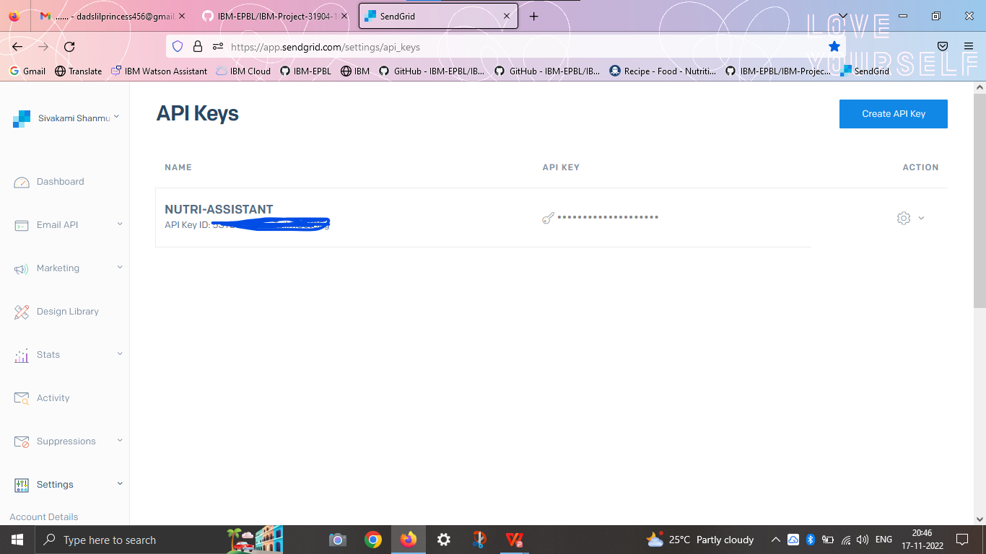

STEP 03:
INSTALL PACKAGE- >pip install send-grid

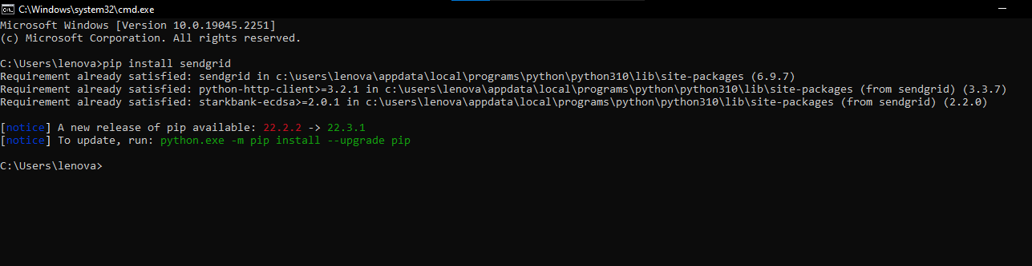

STEP 04:
SEND MAIL

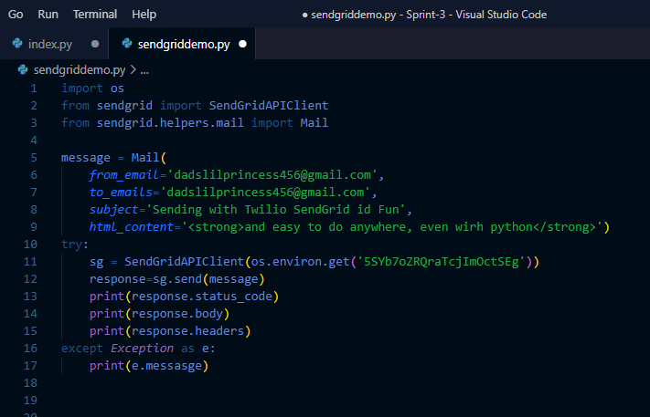

STEP 05:
INTEGRATE WITH PYTHON

